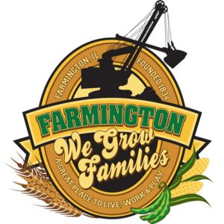
FARMINGTON CITY COUNCIL
May 20, 2024 Amended
AGENDA
CITY COUNCIL CHAMBERS

6:00 P.M.
322 E. FORT STREET, FARMINGTON IL 61531

Call to Order
Pledge of Allegiance

Roll Call

Minutes
Regular Session: 5-6-2024

Correspondence
- Thank you: Hunter Darsham

Cemetery Minutes

Old Business

- None

New Business

- Proclamation: Poppy Day
- Discussion/Possible Action: Donation to 4th of July
- Discussion/Possible Action: Resolution 2024-01 Sale of 33 N East St.
- Discussion/Possible Action: Resolution 2024-02 Sale of West Vernon St. property to Mid Century
- Discussion/Possible Action: Sale of 63 W Pearl St.
- Discussion/Possible Action: CEDC Recommendations
- Discussion/Possible Action: Ordinance 2024-05 Non-Tif Redevelopment Grant
- Discussion/Possible Action: Ordinance 2024-06 Storm Sewer Easement
- Discussion/Possible Action: Ordinance 2024-07 Sewer Easement

Committee Reports:

Finance/Ordinance: Ald. Crusen Streets/Sidewalks/Garbage: Ald. Gilles
Public Safety: Ald. Boggs Parks and Recreation: Ald. Smith
Sewer: Ald. Fleming Public Grounds and Buildings: Ald. Rose

General Comments

Adjournment

