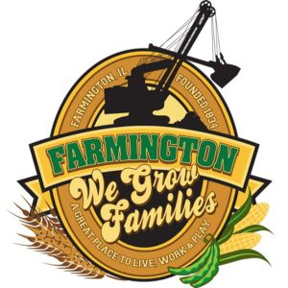

FARMINGTON CITY COUNCIL

AGENDA May 6, 2024

CITY COUNCIL CHAMBERS

6:00 P.M.

322 E. FORT STREET, FARMINGTON IL 61531

Call to Order

Pledge of Allegiance

Roll Call:

Minutes

Regular Session: April 15, 2024

Correspondence

Bills Presented for Payment

Balance of Accounts

TIF Report

Police Department Report

Old Business

Discussion: Pool Ordinance

New Business

Discussion/Possible Action: Planning Commission Resignation

Discussion/Possible Action: Sale of 33 North East Street

Discussion/Possible Action: Garbage Cans for Downtown Fort

Discussion/Possible Action: Fiscal Year 25 Residential TIF Grants

Discussion/Possible Action: Fiscal Year 25 Downtown Facade TIF Grants

Discussion/ Possible Action: Resolution to appoint Shelby Zeigler as IMRF Representative

Discussion/Possible Action: Dimmit park slide replacement

Discussion/Possible Action: Reed Park Slide Replacement

Discussion/Possible Action: Restroom Cleaning

Committee Reports

Finance/Ordinance: Crusen Streets/Sidewalks/Garbage: Gilles

Public Safety: Boggs Parks and Recreation: Smith

Sewer: Fleming Public Grounds and Buildings: Rose

General Comments

Adjournment

https://www.youtube.com/@cityoffarmingtonil