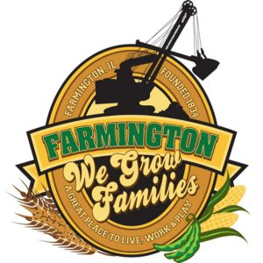
FARMINGTON CITY COUNCIL

July 15, 2024 AGENDA
CITY COUNCIL CHAMBERS

6:00 P.M.
322 E. FORT STREET, FARMINGTON IL 61531

Call to Order
Pledge of Allegiance

Roll Call

End Zone Communication - Jacquelyn Albertz

Minutes
Regular Session: 07/01/2024

Correspondence

- Knights of Columbus Tootsie Roll Drive

Admin Report

Old Business

- Discussion/Possible Action: Executive Session Minutes

New Business

Committee Reports:

Finance/Ordinance: Ald. Crusen Streets/Sidewalks/Garbage: Ald. Gilles
Public Safety: Ald. Boggs Parks and Recreation: Ald. Smith
Sewer: Ald. Fleming Public Grounds and Buildings: Ald. Rose

General Comments

Adjournment

