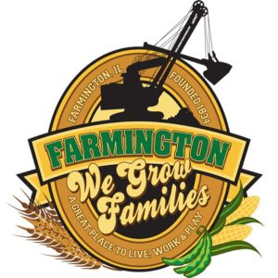
FARMINGTON CITY COUNCIL

AGENDA
CITY COUNCIL CHAMBERS
September 16, 2024
6:00 P.M.
322 E. FORT STREET, FARMINGTON IL 61531

Call to Order
Pledge of Allegiance

Roll Call

Minutes
Regular Session: 9-3-2024

Correspondence

Cemetery Minutes

Admin Report

Old Business

New Business

- Discussion/Possible Action: Purchase of a Tree in Memory of Mayor Stobaugh
- Discussion/Possible Action: Ordinance 2024-12 TIF Dana Cardenas
- Discussion/Possible Action: Ordinance 2024-13 Vacating a portion of Adrienne Street
- Discussion/Possible Action: Ordinance 2024- Combining Planning and Zoning Commision
- Discussion: Salaries for Elected Officials

Committee Reports:

Finance/Ordinance: Ald. Crusen Streets/Sidewalks/Garbage: Ald. Gilles
Public Safety: Ald. Boggs Parks and Recreation: Ald. Smith
Sewer: Ald. Fleming Public Grounds and Buildings: Ald. Rose

General Comments

Adjournment

